Lateral Face

Definition
# Source: AI Source: Provided by: [Data Path: Persons Table -> ID Column: 1, Name_En Column: Motasem Essam] -> From: [ChatGPT] on [7/25/2026]
A lateral face is a face of a three-dimensional solid that forms part of its side surface rather than its base. In a prism, lateral faces connect the corresponding edges of the two bases. In a pyramid, lateral faces connect the base edges to the apex.
Lateral faces may be polygonal, as in prisms and pyramids, or curved surfaces may form the lateral surface of solids such as cylinders and cones.
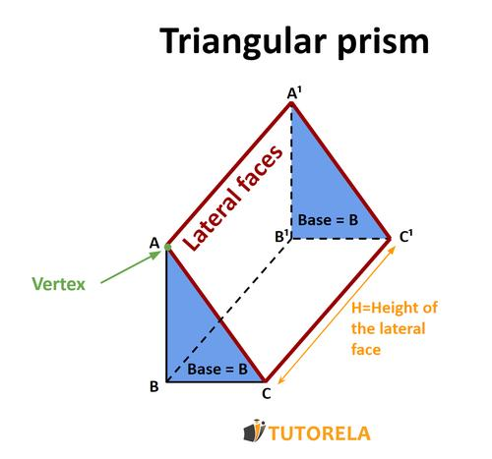
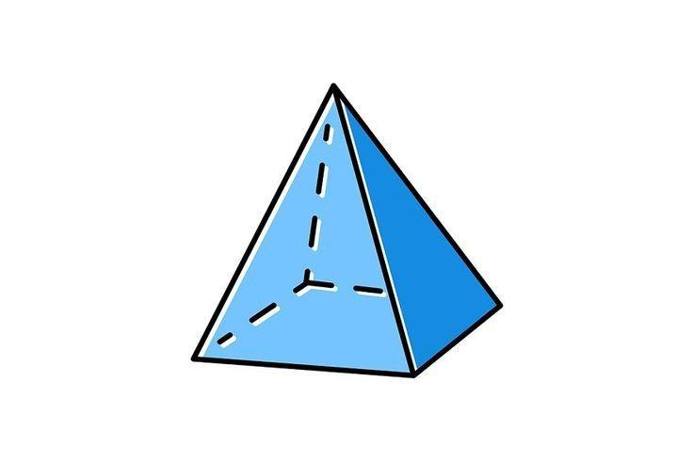


Simple Definition
# Source: AI Source: Provided by: [Data Path: Persons Table -> ID Column: 1, Name_En Column: Motasem Essam] -> From: [ChatGPT] on [7/25/2026]
A lateral face is a side face of a solid, excluding its base face or faces.
Examples:
- The four triangular sides of a square pyramid.
- The three rectangular sides of a triangular prism.
- The four rectangular sides of a rectangular prism.
- The curved side surface of a cylinder.
In strict terminology, the flat polygonal sides of polyhedra are called lateral faces. For cylinders and cones, the corresponding non-base part is more precisely called the lateral surface, because it is curved rather than polygonal.

Classification Tree
# Source: AI Source: Provided by: [Data Path: Persons Table -> ID Column: 1, Name_En Column: Motasem Essam] -> From: [ChatGPT] on [7/25/2026]
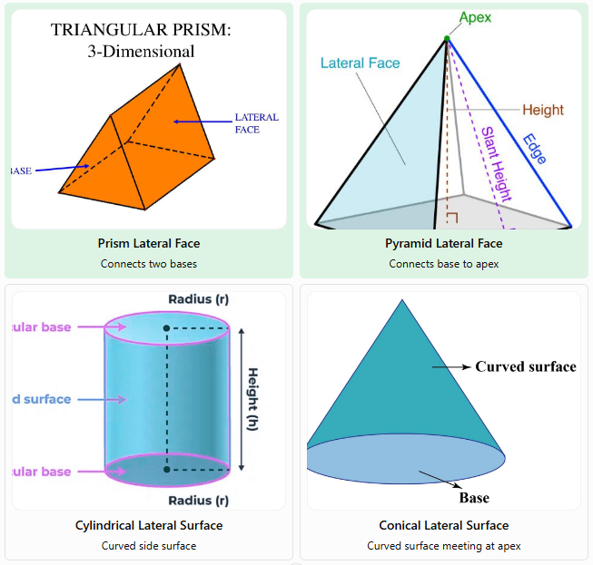
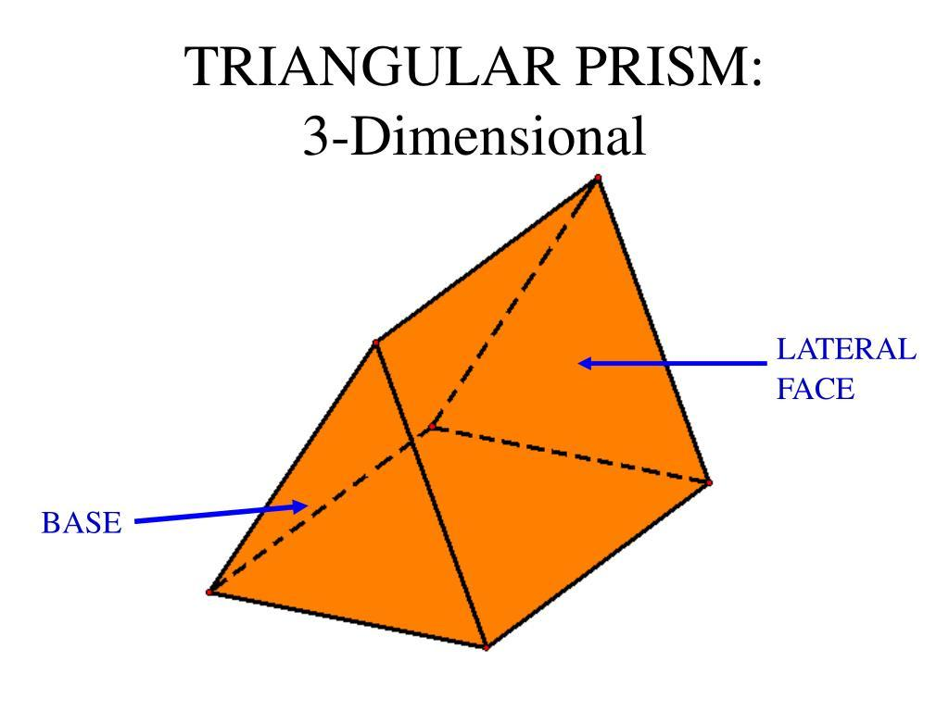
Prism Lateral Face
Connects two bases
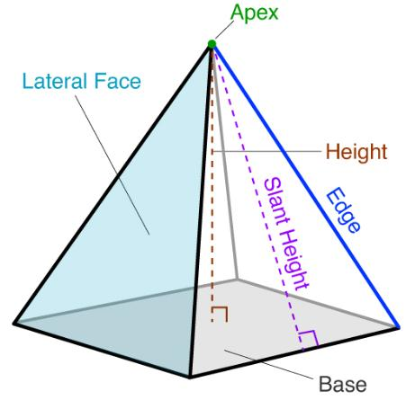
Pyramid Lateral Face
Connects base to apex
Cylindrical Lateral Surface
Curved side surface
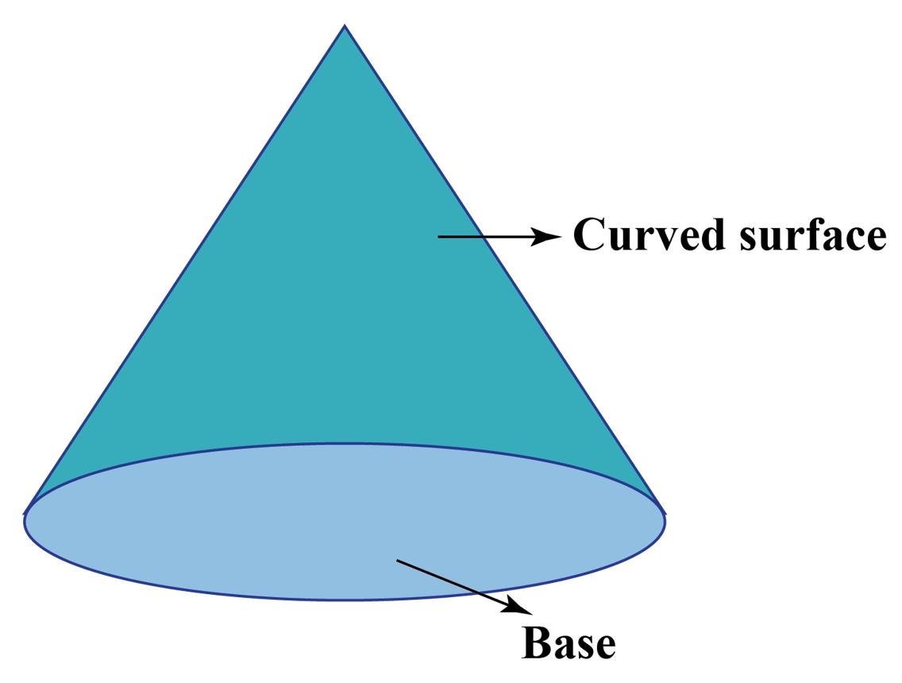
Conical Lateral Surface
Curved surface meeting at apex

Key Characteristics
# Source: AI Source: Provided by: [Data Path: Persons Table -> ID Column: 1, Name_En Column: Motasem Essam] -> From: [ChatGPT] on [7/25/2026]
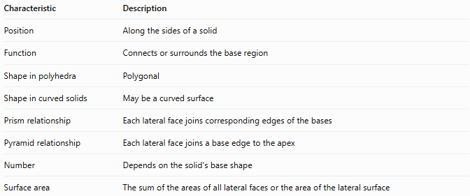
Characteristic | Description
Position | Along the sides of a solid
Function | Connects or surrounds the base region
Shape in polyhedra | Polygonal
Shape in curved solids | May be a curved surface
Prism relationship | Each lateral face joins corresponding edges of the bases
Pyramid relationship | Each lateral face joins a base edge to the apex
Number | Depends on the solid's base shape
Surface area | The sum of the areas of all lateral faces or the area of the lateral surface

Geometric Representation
# Source: AI Source: Provided by: [Data Path: Persons Table -> ID Column: 1, Name_En Column: Motasem Essam] -> From: [ChatGPT] on [7/25/2026]
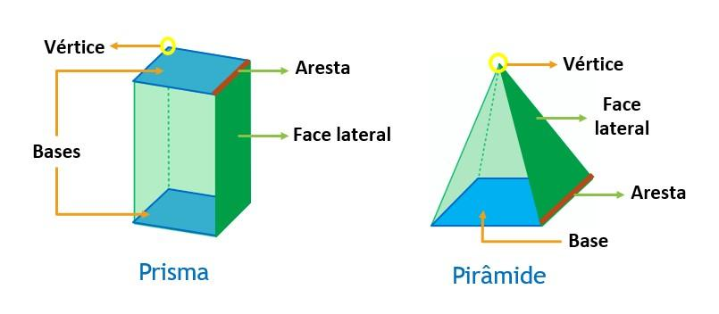

A. Lateral faces of a prism
# Source: AI Source: Provided by: [Data Path: Persons Table -> ID Column: 1, Name_En Column: Motasem Essam] -> From: [ChatGPT] on [7/25/2026]
A prism with an $n$-sided polygonal base has $n$ lateral faces.
For example, a triangular prism has three lateral faces. A right triangular prism has three rectangular lateral faces, while an oblique triangular prism generally has parallelogram-shaped lateral faces.

B. Lateral faces of a pyramid
# Source: AI Source: Provided by: [Data Path: Persons Table -> ID Column: 1, Name_En Column: Motasem Essam] -> From: [ChatGPT] on [7/25/2026]
A pyramid with an $n$-sided polygonal base has $n$ triangular lateral faces.
For example, a square pyramid has four triangular lateral faces, and a pentagonal pyramid has five.

C. Lateral surface of a cylinder
# Source: AI Source: Provided by: [Data Path: Persons Table -> ID Column: 1, Name_En Column: Motasem Essam] -> From: [ChatGPT] on [7/25/2026]
A cylinder has one continuous curved lateral surface connecting its two circular bases. It does not have polygonal lateral faces.

D. Lateral surface of a cone
# Source: AI Source: Provided by: [Data Path: Persons Table -> ID Column: 1, Name_En Column: Motasem Essam] -> From: [ChatGPT] on [7/25/2026]
A cone has one continuous curved lateral surface extending from its circular base to its apex.

Mathematical Representation and Formulas

A. Number of lateral faces
# Source: AI Source: Provided by: [Data Path: Persons Table -> ID Column: 1, Name_En Column: Motasem Essam] -> From: [ChatGPT] on [7/25/2026]
For an $n$-sided prism:
$$F_{L}=n$$
For an $n$-sided pyramid:
$$F_{L}=n$$
Here, $F_{L}$ is the number of lateral faces. In both cases, $n$ is the number of sides of the base polygon.
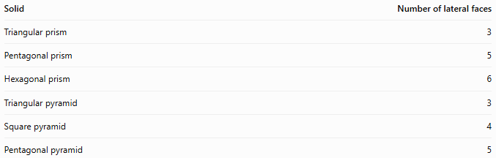
Solid | Number of lateral faces
Triangular prism | 3
Pentagonal prism | 5
Hexagonal prism | 6
Triangular pyramid | 3
Square pyramid | 4
Pentagonal pyramid | 5

B. Lateral surface area of a right prism
# Source: AI Source: Provided by: [Data Path: Persons Table -> ID Column: 1, Name_En Column: Motasem Essam] -> From: [ChatGPT] on [7/25/2026]
For a right prism:
$$LSA=ph$$
where:
- $p$ is the perimeter of the base.
- $h$ is the perpendicular height of the prism.
- $LSA$ is the lateral surface area.

C. Lateral surface area of a regular right pyramid
# Source: AI Source: Provided by: [Data Path: Persons Table -> ID Column: 1, Name_En Column: Motasem Essam] -> From: [ChatGPT] on [7/25/2026]
For a regular right pyramid:
$$LSA=\frac{12}{p}l$$
where $p$ is the perimeter of the base and $l$ is the slant height measured along a triangular lateral face.

D. Lateral surface area of a cylinder
# Source: AI Source: Provided by: [Data Path: Persons Table -> ID Column: 1, Name_En Column: Motasem Essam] -> From: [ChatGPT] on [7/25/2026]
$$LSA=2πrh$$
Here, $r$ is the radius of the circular base and $h$ is the cylinder's height.

E. Lateral surface area of a right circular cone
# Source: AI Source: Provided by: [Data Path: Persons Table -> ID Column: 1, Name_En Column: Motasem Essam] -> From: [ChatGPT] on [7/25/2026]
$$LSA=πrl$$
Here, $r$ is the base radius and $l$ is the slant height.
For a right circular cone, the relationship between vertical height, radius, and slant height is
$$l=\sqrt{r^{2}+h^{2}}$$

Worked Examples
# Source: AI Source: Provided by: [Data Path: Persons Table -> ID Column: 1, Name_En Column: Motasem Essam] -> From: [ChatGPT] on [7/25/2026]
Example 1: Counting the lateral faces of a hexagonal prism
A hexagonal prism has a base with six sides.
Step 1: Identify the number of base sides.
$$n=6$$
Step 2: Apply the prism formula.
$$F_{L}=n=6$$
Answer: The hexagonal prism has 6 lateral faces and 2 hexagonal base faces, giving 8 faces in total.
Example 2: Finding the lateral surface area of a right prism
A right prism has a rectangular base measuring $5\text{ cm}$ by $3\text{ cm}$ and a height of $10\text{ cm}$. Find its lateral surface area.
Step 1: Calculate the base perimeter.
$$p=2\left(5+3\right)=16\text{ cm}$$
Step 2: Apply the formula.
$$LSA=ph$$
$$LSA=16\left(10\right)=160{\text{ cm}}^{2}$$
Answer: The lateral surface area is $160{\text{ cm}}^{2}$.
Example 3: Finding the lateral surface area of a square pyramid
A regular square pyramid has a base side length of $8\text{ cm}$ and a slant height of $5\text{ cm}$. Find its lateral surface area.
Step 1: Calculate the base perimeter.
$$p=4\left(8\right)=32\text{ cm}$$
Step 2: Apply the formula.
$$LSA=\frac{12}{p}l$$
$$LSA=\frac{12}{\left(32\right)}\left(5\right)=80{\text{ cm}}^{2}$$
Answer: The lateral surface area is \(80\text{ cm}^2\).
Example 4: Finding the lateral surface area of a cylinder
A cylinder has a radius of $3\text{ cm}$ and a height of $7\text{ cm}$.
$$LSA=2πrh$$
$$LSA=2π\left(3\right)\left(7\right)=42π{\text{ cm}}^{2}$$
Approximately,
$$LSA≈131.95{\text{ cm}}^{2}$$
Answer: The lateral surface area is $42π{\text{ cm}}^{2}$, or approximately $131.95{\text{ cm}}^{2}$.

Comparison with Related Concepts
# Source: AI Source: Provided by: [Data Path: Persons Table -> ID Column: 1, Name_En Column: Motasem Essam] -> From: [ChatGPT] on [7/25/2026]
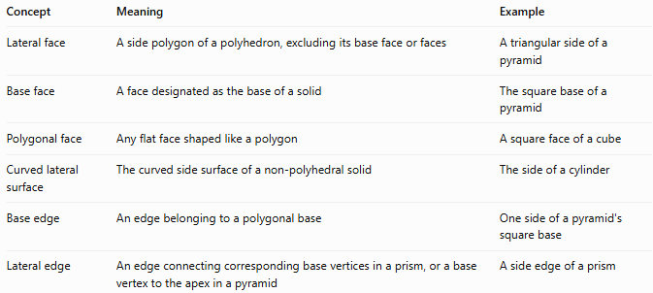
Concept | Meaning | Example
Lateral face | A side polygon of a polyhedron, excluding its base face or faces | A triangular side of a pyramid
Base face | A face designated as the base of a solid | The square base of a pyramid
Polygonal face | Any flat face shaped like a polygon | A square face of a cube
Curved lateral surface | The curved side surface of a non-polyhedral solid | The side of a cylinder
Base edge | An edge belonging to a polygonal base | One side of a pyramid's square base
Lateral edge | An edge connecting corresponding base vertices in a prism, or a base vertex to the apex in a pyramid | A side edge of a prism
Important distinction: Every lateral face of a polyhedron is a polygonal face, but not every polygonal face is a lateral face. A base face is also polygonal when its shape is a polygon.

Applications of Lateral Faces
# Source: AI Source: Provided by: [Data Path: Persons Table -> ID Column: 1, Name_En Column: Motasem Essam] -> From: [ChatGPT] on [7/25/2026]
Lateral faces and surfaces are useful in several fields:
- Architecture: Estimating the material required to cover the sides of buildings and roofs.
- Packaging: Calculating the material needed for the sides of boxes and containers.
- Engineering: Designing prismatic and pyramidal components.
- Manufacturing: Determining the amount of sheet material needed to construct solid objects.
- Mathematics: Calculating lateral surface area, total surface area, and volume-related measurements.

Key Points
# Source: AI Source: Provided by: [Data Path: Persons Table -> ID Column: 1, Name_En Column: Motasem Essam] -> From: [ChatGPT] on [7/25/2026]
- A lateral face is a side face, excluding the base face or faces.
- A prism with an $n$-sided base has $n$ lateral faces.
- A pyramid with an $n$-sided base also has $n$ lateral faces.
- Lateral faces of a right prism are rectangles.
- Lateral faces of a pyramid are triangles.
- Cylinders and cones have curved lateral surfaces rather than polygonal lateral faces.
- Lateral surface area excludes the area of the base or bases.

Conclusion
# Source: AI Source: Provided by: [Data Path: Persons Table -> ID Column: 1, Name_En Column: Motasem Essam] -> From: [ChatGPT] on [7/25/2026]
A lateral face in solid geometry is a side face that forms part of a solid's boundary but is not one of its base faces. Lateral faces are essential for understanding the structure of prisms and pyramids, while the related concept of a lateral surface applies to cylinders and cones. Identifying these surfaces makes it easier to calculate lateral and total surface areas.

